**Lab 5: Functions**

The aim of this lab is to allow you to explore working with functions.

**Part 1:** Convert the factorial lab to use functions

The aim of this part of the lab is to wrap your factorial logic up into a function. This should allow the factorial function to be called with different values so that the user of the function can ask for the factorial of say -1, 0, 1, 3, 5, 7 etc to be calculated, for example:

factorial(-1)

factorial(0)

factorial(1)

factorial(3)

factorial(5)

factorial(7)

To do this we need to wrap the code we previous created into a function. This function must take a parameter which is the value to be used in calculating the factorial.

To do this create a new file called factorial2.js.

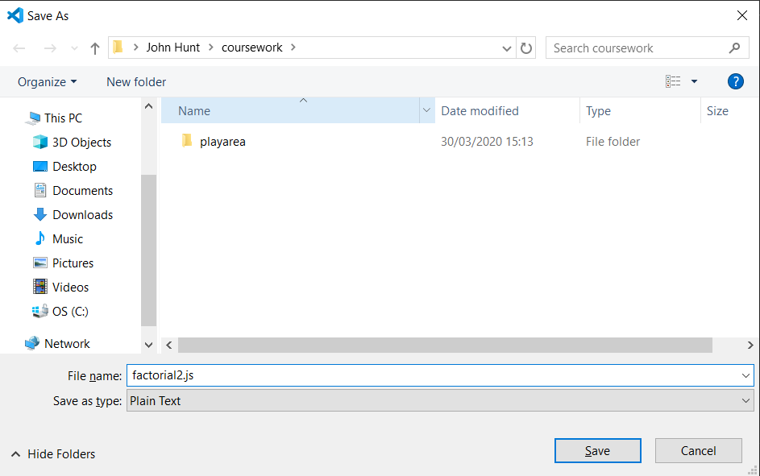

In this newly created file we will add a console.log() statement to allow us to check that the program is running.

Enter the following into the file:

console.log("Starting factorial calculation program")

Save the file and run it.

Once that is working correctly add a simple function definition. We will call the function factorial and it should take a number. For the moment all the function will do it so print out whatever number it has been given, for example:

console.log("Starting factorial calculation program")

function factorial(number) {

  console.log('Calculating factorial ', number)

}

To test this out after the function has been defined make a call to the function. This is done by entering the name of the function and providing a value to be used when running the function, for example:

factorial(5)

Now save and run your program. The output should be:

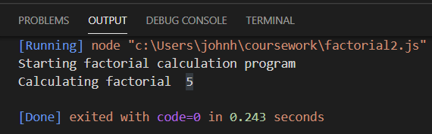

We can now implement the details in the factorial() function.

To do this all you need to do is to copy the logic you wrote in the last practical for calculating the factorial number from that file into this file and place it within the scope of the function (between the curly brackets). For example:

console.log("Starting factorial calculation program")

function factorial(number) {

  console.log('Calculating factorial ', number)

  if (number < 0) {

    console.log('Factorial is not defined for negative numbers')

  } else if (number == 0) {

    console.log("0! factorial is 1");

  } else {

    let factorial = 1;

    for (let i = 1; i <= number; i++) {

      factorial = factorial * i;

    }

    console.log(number + "! factorial is", factorial);

  }

}

factorial(5)

Notice we have not copied the line that initialised the number in the previous example; if you copied that part remove it as the value to calculate is now provided when the function is called.

Now save and run this program. The output should now be:

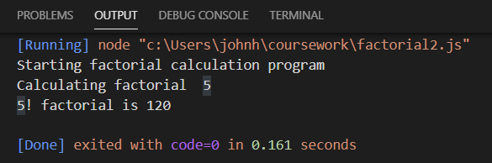

Finally you can add further calls to your factorial() function providing different values to be calculated. This is done by adding the following:

factorial(-1);

factorial(0);

factorial(1);

factorial(3);

factorial(5);

factorial(7);

This means instead of one call to factorial() providing the value 5 we are now making several calls to that function and providing the values -1, 0, 1, 3, 5 and 7.

The output for this from the sample solution is:

Starting factorial calculation program

Calculating factorial -1

Factorial is not defined for negative numbers

Calculating factorial 0

0! factorial is 1

Calculating factorial 1

1! factorial is 1

Calculating factorial 3

3! factorial is 6

Calculating factorial 5

5! factorial is 120

Calculating factorial 7

7! factorial is 5040

**Part 2**: Create a calculator function

If you are feeling adventurous and have finished Part 1 then try this project.

You should create a function that takes three parameters:

1. The operation to perform such as “+”, “-“, “/” or “*”
2. An operand x
3. An operand y

Based on the operation specified it should perform a numeric calculation and return the result.

It should thus be able to execute the following code:

console.log('calculator("+", 2, 3): ', calculator("+", 2, 3))

console.log('calculator("-", 2, 3): ', calculator("-", 2, 3))

console.log('calculator("*", 2, 3): ', calculator("*", 2, 3))

console.log('calculator("/", 6, 3): ', calculator("/", 6, 3))

console.log('calculator("&", 2, 3): ', calculator("&", 2, 3))

The output from this program for the sample solution is:

calculator("+", 2, 3): 5

calculator("-", 2, 3): -1

calculator("*", 2, 3): 6

calculator("/", 6, 3): 2

calculator("&", 2, 3): 0

The calculator function will need to use an if / else if statement to determine the correct calculation to run.